Supporting Information for

**Competitive Adsorption of Nitrogen and Hydrogen on Catalyst Surfaces: Implications for Optimizing Ammonia Synthesis**

Supplementary information for optional Enhancements

1. **Adding additional move (particle swap)**

* **Detailed code was uploaded to the Git-hub repository**

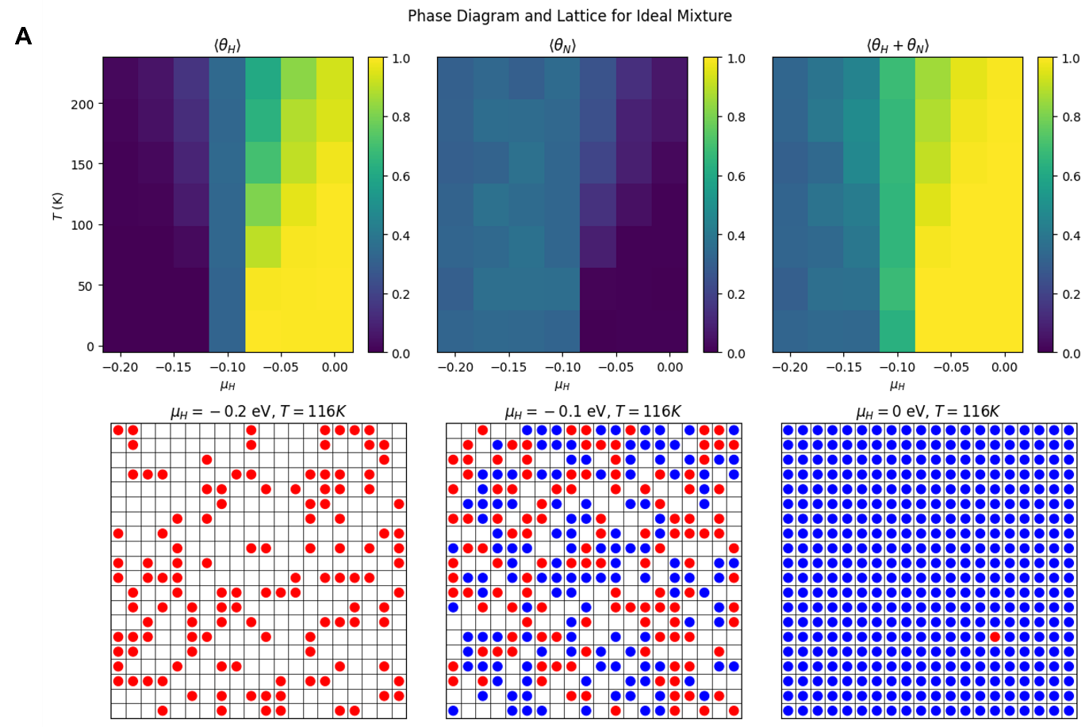

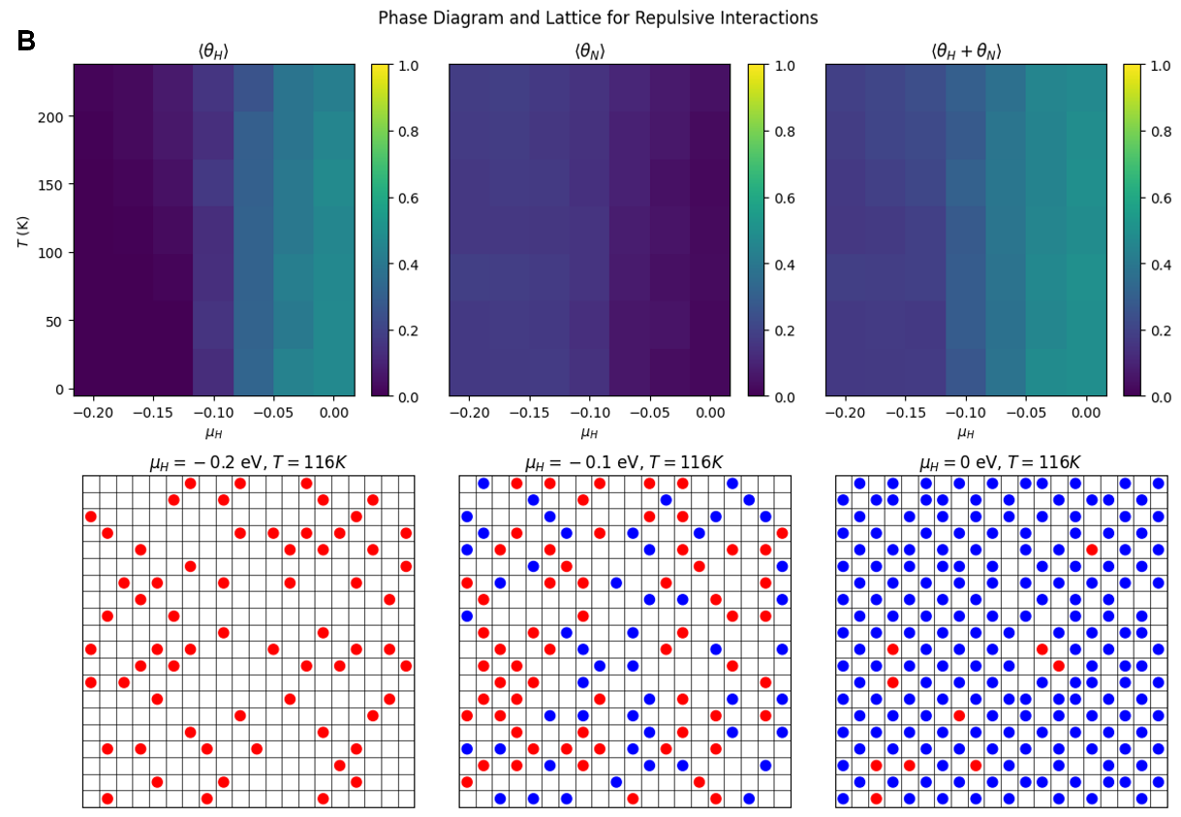

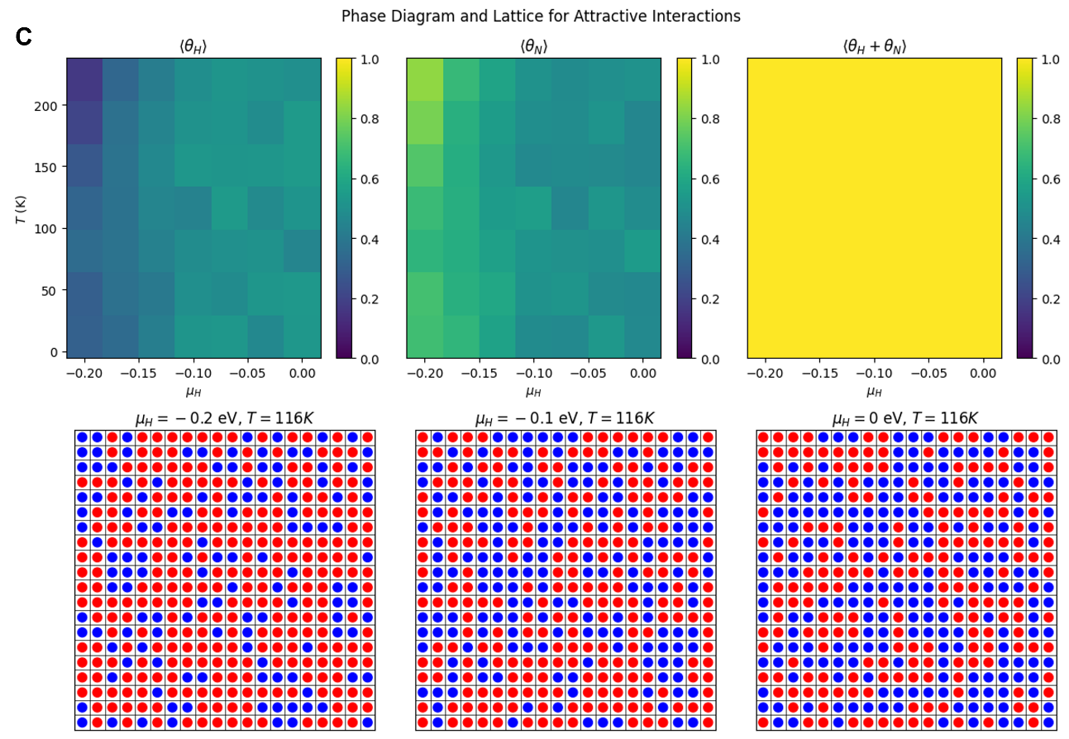

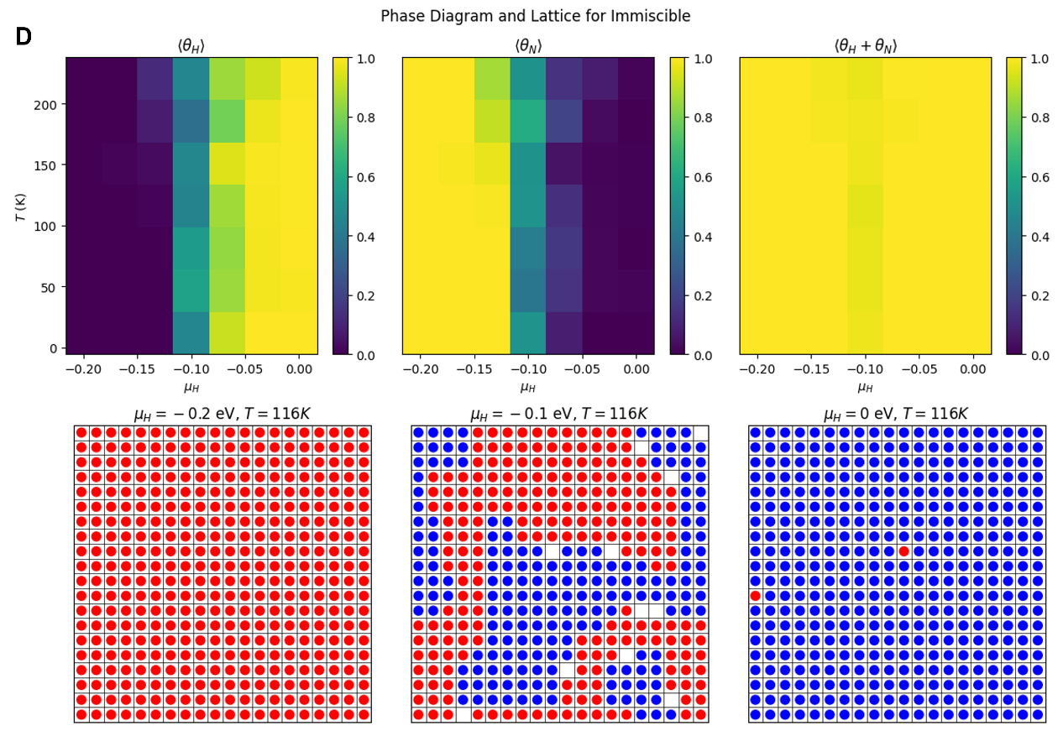

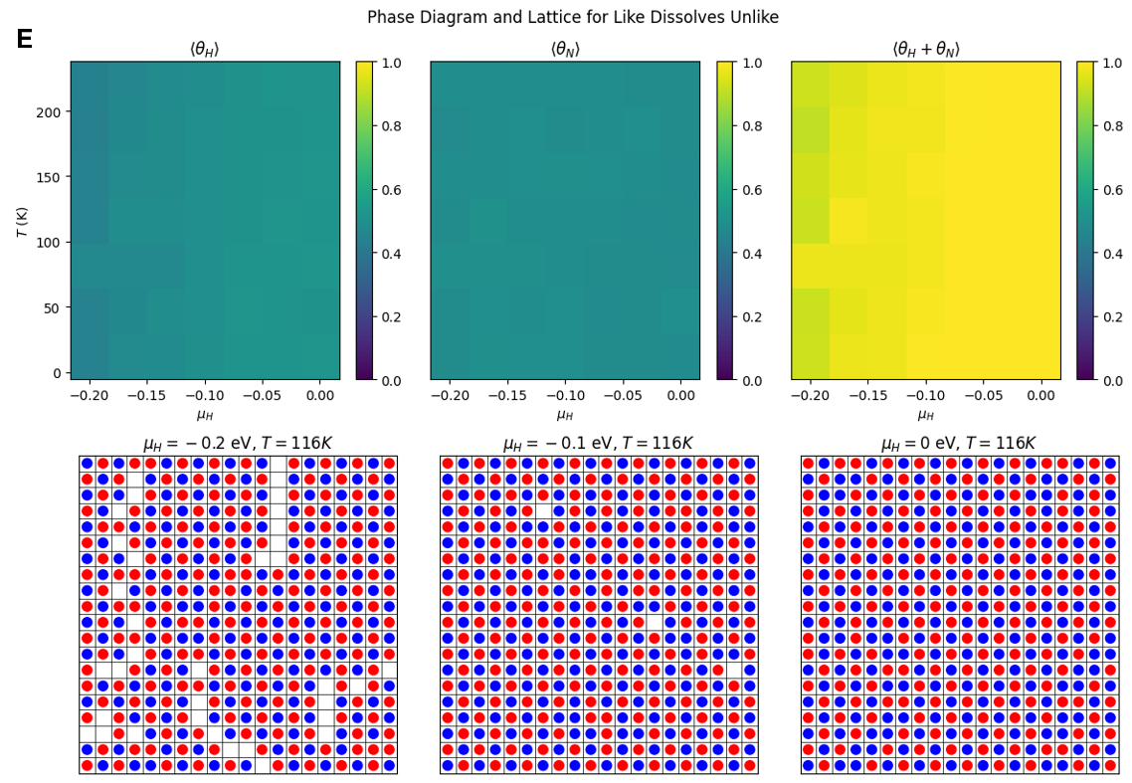

**Figure S1**. Phase diagram and lattice after applying swap move introduction for (A) ideal mixture (B) repulsive interaction (C) attractive interaction (D) immiscible case, and (E) like dissolves unlike case. The red circle denotes nitrogen and blue circle denotes hydrogen.

The particle swap move introduces an additional degree of freedom to the simulation. It allows the enhanced exploration of the adsorption lattice and providing a more thorough sampling of the configuration space (**Figure S1A-E**). The particle swap move enhances adsorption efficiency by allowing particles to explore more configurations and uniformly occupy the lattice, which is particularly beneficial in scenarios with repulsive interactions or immiscibility. This move increases total adsorption coverage, especially with competing adsorption or repulsive forces, while reducing clustering of the same species by dispersing particles more evenly. In addition, for attractive interactions or "like dissolves unlike" scenarios, the particle swap promotes better co-adsorption and mixing, optimizing catalyst site availability for nitrogen and hydrogen.

1. **The effects of lattice size**

* **Detailed code was uploaded to the Git-hub repository**

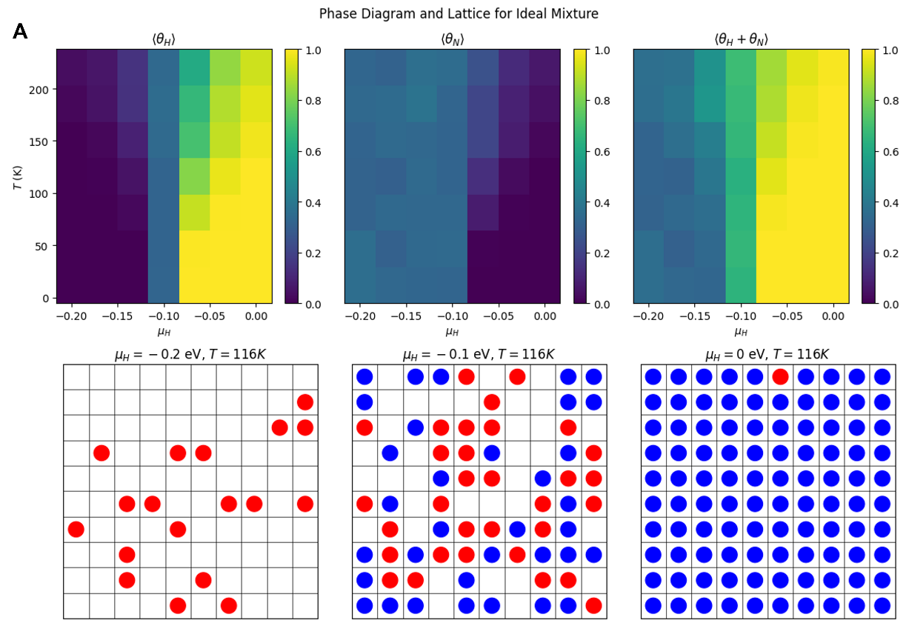

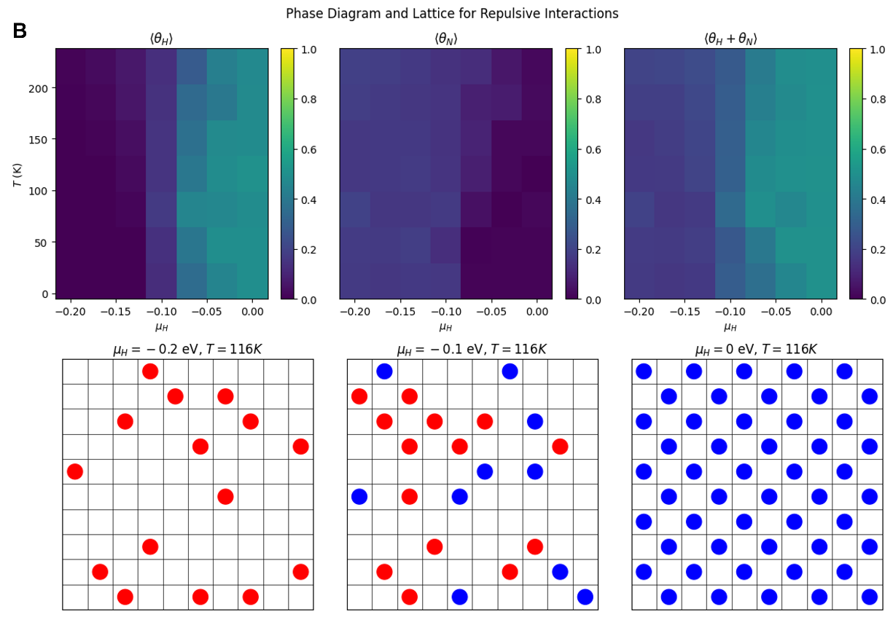

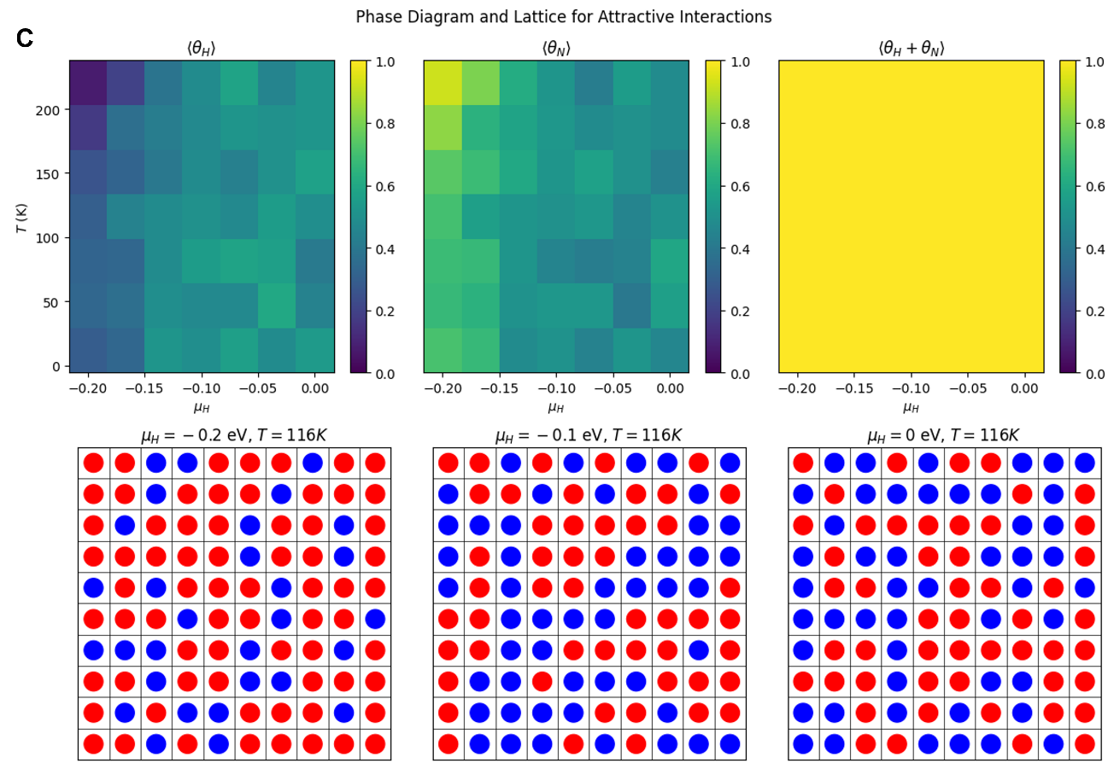

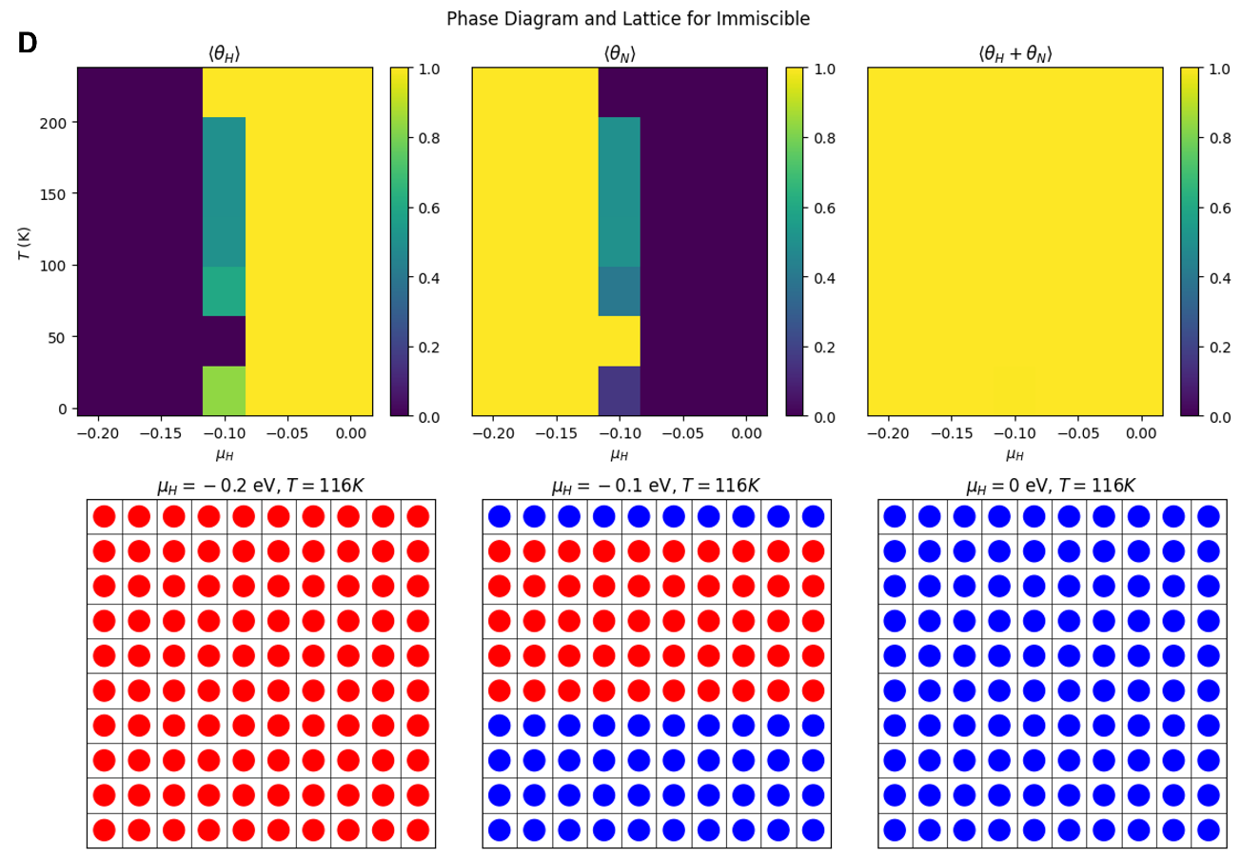

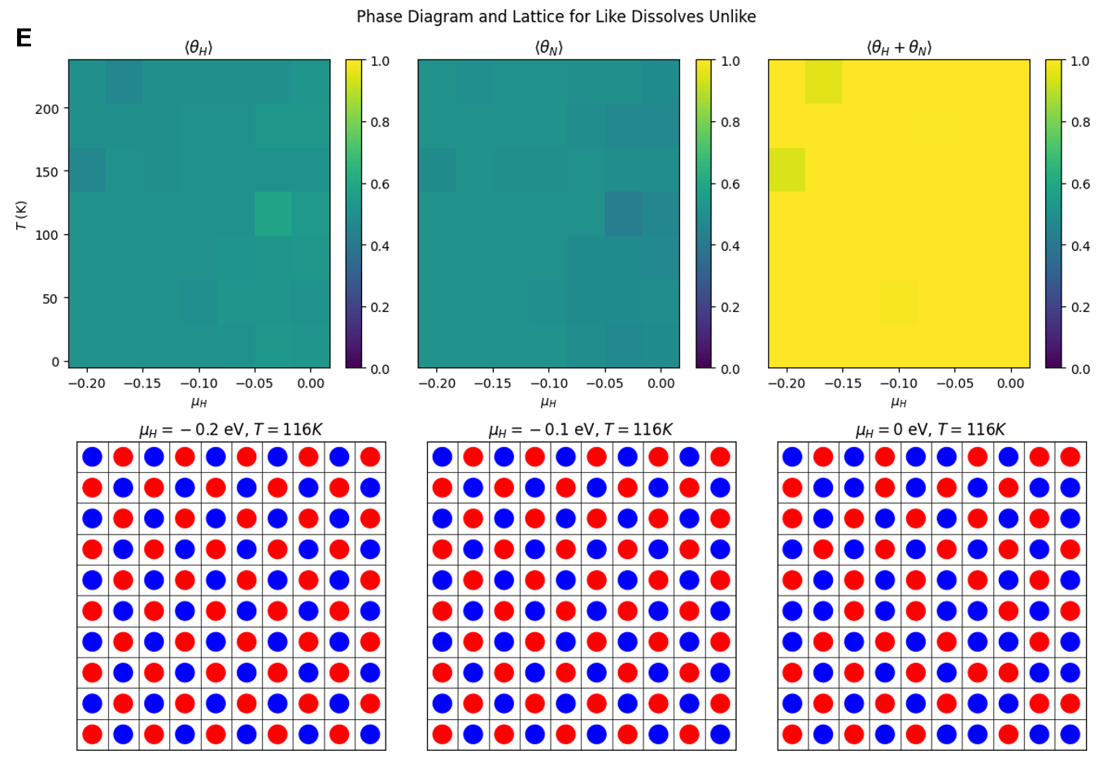

**Figure S2**. Phase diagram and lattice after applying 10x10 lattice size for (A) ideal mixture (B) repulsive interaction (C) attractive interaction (D) immiscible case, and (E) like dissolves unlike case. The red circle denotes nitrogen and blue circle denotes hydrogen.

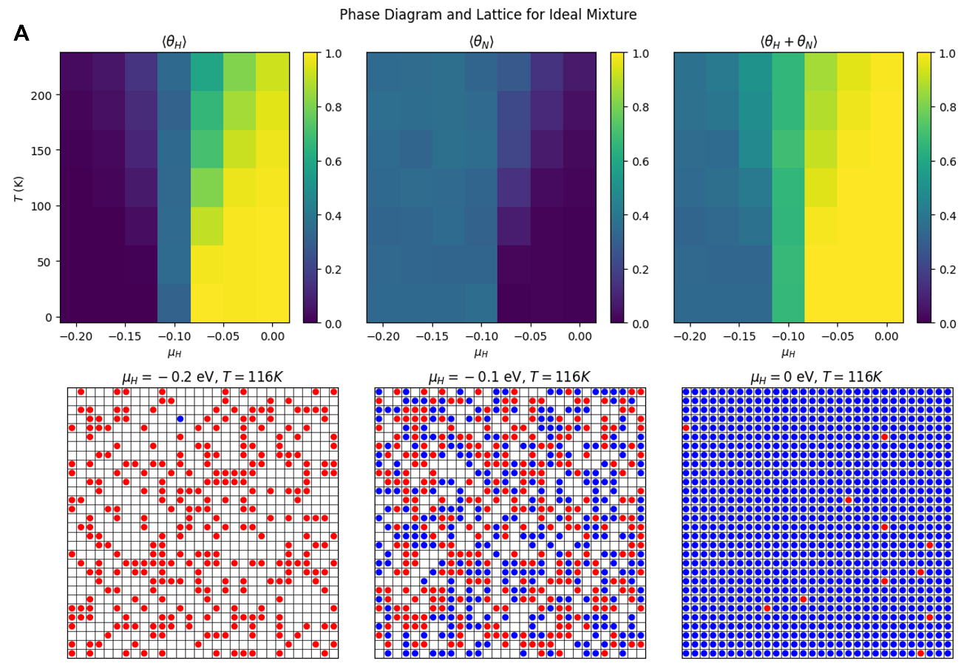

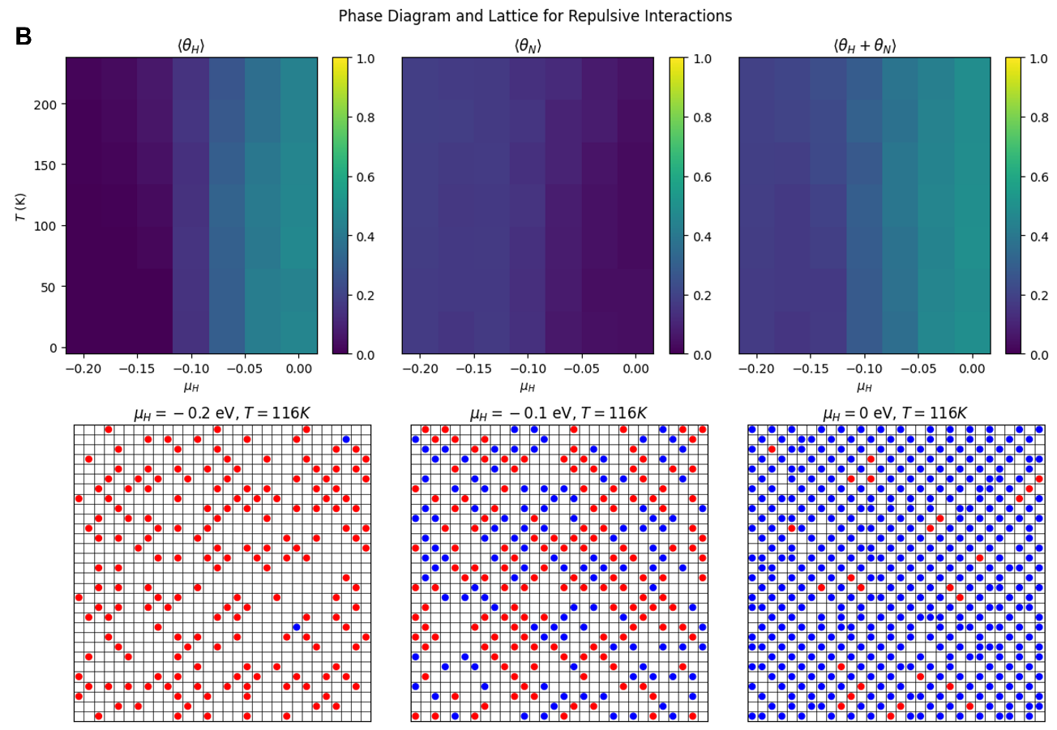

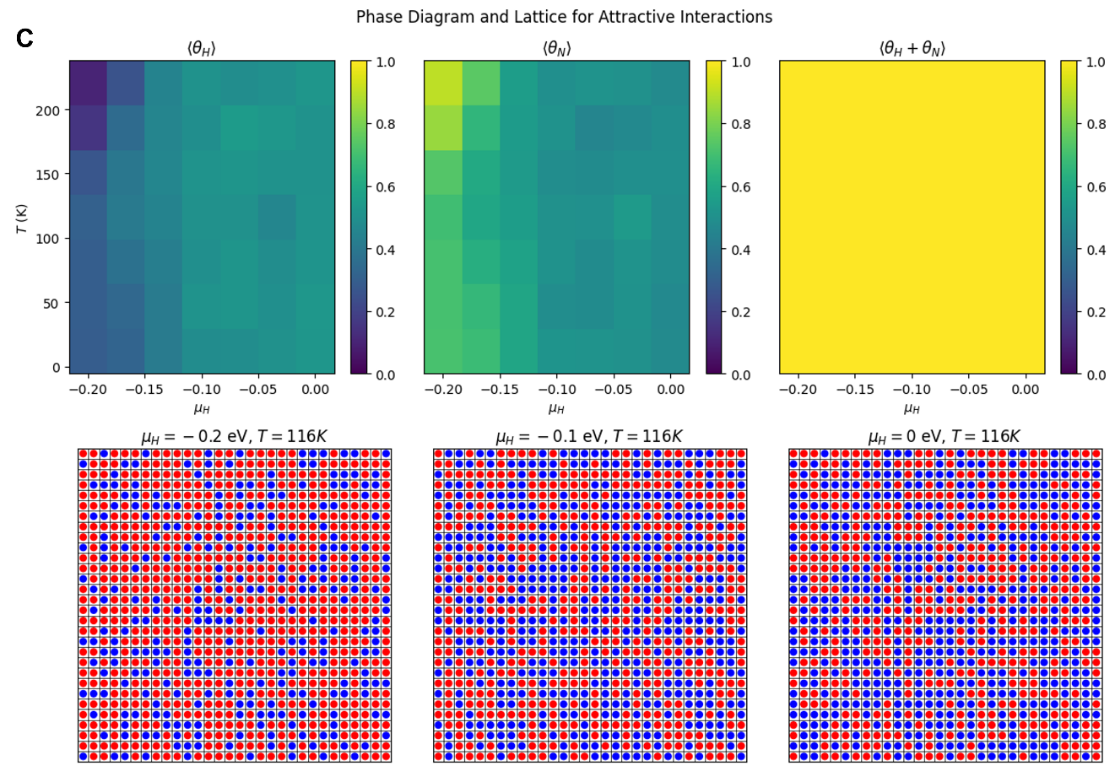

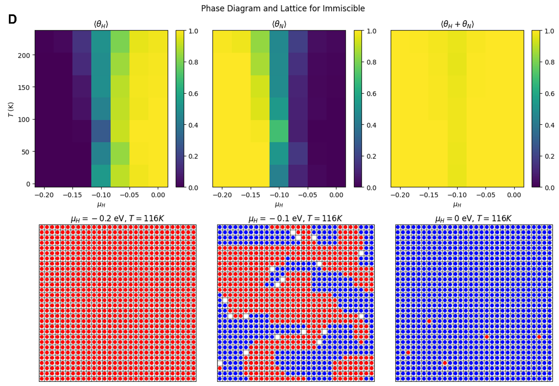

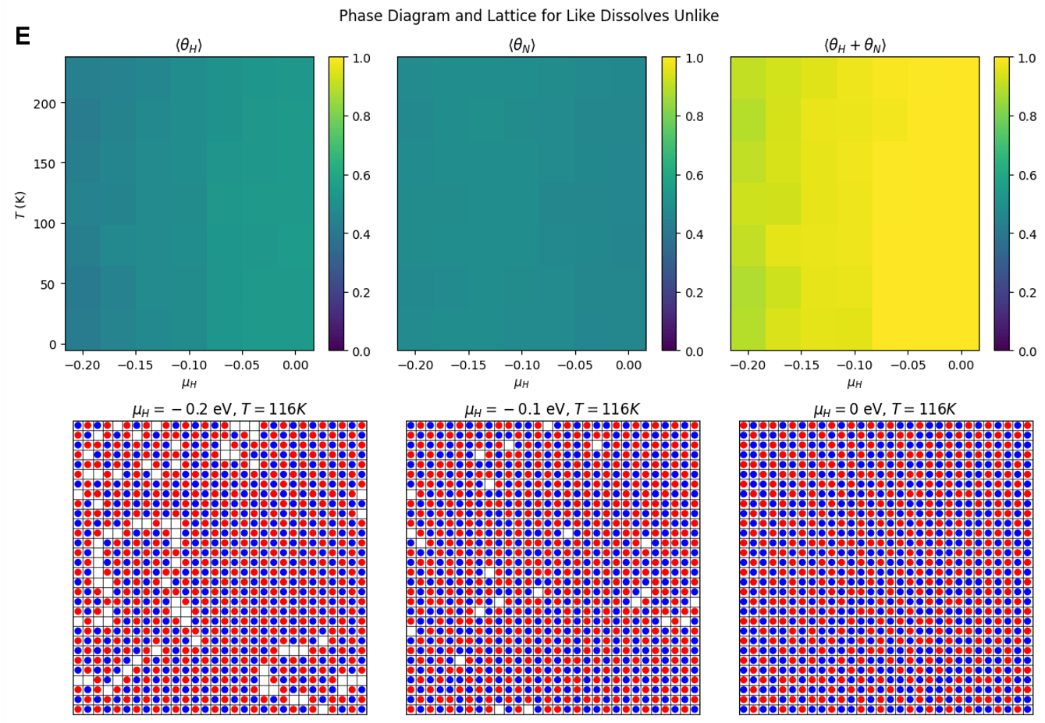

**Figure S3**. Phase diagram and lattice after applying 30x30 lattice size for (A) ideal mixture (B) repulsive interaction (C) attractive interaction (D) immiscible case, and (E) like dissolves unlike case. The red circle denotes nitrogen and blue circle denotes hydrogen.

Increasing the lattice size results in more gradual and consistent coverage changes for nitrogen and hydrogen, while smaller lattices exhibit sharp transitions due to limited sites and intense competition (**Figure S2A-E and S3A-E**). Specifically, the effects of attractive or repulsive interactions are more pronounced in smaller lattices, where limited space intensifies clustering or segregation, whereas larger lattices allow for more even adsorption. In phase behavior, smaller lattices show sudden transitions, reflecting rapid adsorption or desorption. However, larger lattices provide more sites, allowing smoother transitions across different chemical potentials. For spatial distribution, smaller lattices show pronounced phase separation or clustering, whereas larger lattices facilitate a more homogeneous distribution with smoother boundaries between adsorbates.

1. **The competitive adsorption behavior among three particles**

* **Detailed code was uploaded to the Git-hub repository**

To simulate this case, the third atom was added as oxygen and the parameters are shown below:

|  |  |  |  |  |  |  |  |  |  |
| --- | --- | --- | --- | --- | --- | --- | --- | --- | --- |
| **Cases** | $$ϵ_{N}$$ | $$ϵ_{H}$$ | $$ϵ_{O}$$ | $$ϵ_{NN}$$ | $$ϵ_{HH}$$ | $$ϵ_{OO}$$ | $$ϵ_{NH}$$ | $$ϵ_{NO}$$ | $$ϵ_{OH}$$ |
| Ideal Mixture of Nitrogen and Hydrogen, and Oxygen | -0.1 eV | -0.1 eV | -0.1 eV | 0 eV | 0 eV | 0 eV | 0 eV | 0 eV | 0 eV |
| Repulsive Interactions | -0.1 eV | -0.1 eV | -0.1 eV | 0.05 eV | 0.05 eV | 0.05 eV | 0.05 eV | 0.05 eV | 0.05 eV |
| Attractive Interactions | -0.1 eV | -0.1 eV | -0.1 eV | -0.05 eV | -0.05 eV | -0.05 eV | -0.05 eV | -0.05 eV | -0.05 eV |
| Immiscible Nitrogen, Hydrogen, and Oxygen | -0.1 eV | -0.1 eV | -0.1 eV | -0.05 eV | -0.05 eV | 0.05 eV | 0.05 eV | 0.05 eV | 0.05 eV |
| Like Dissolves Unlike | -0.1 eV | -0.1 eV | -0.1 eV | 0.05 eV | 0.05 eV | -0.05 eV | -0.05 eV | -0.05 eV | -0.05 eV |

As a result, the phase diagrams and lattice for each case were obtained.

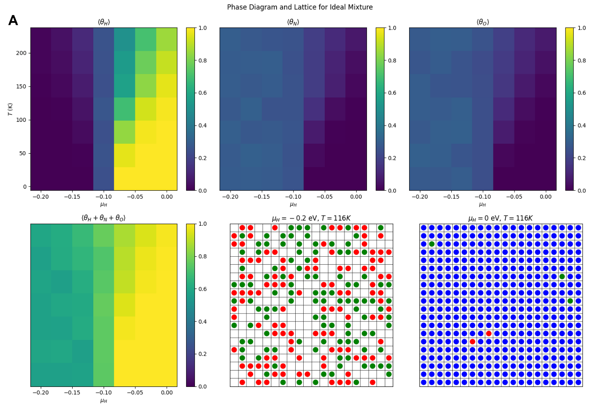

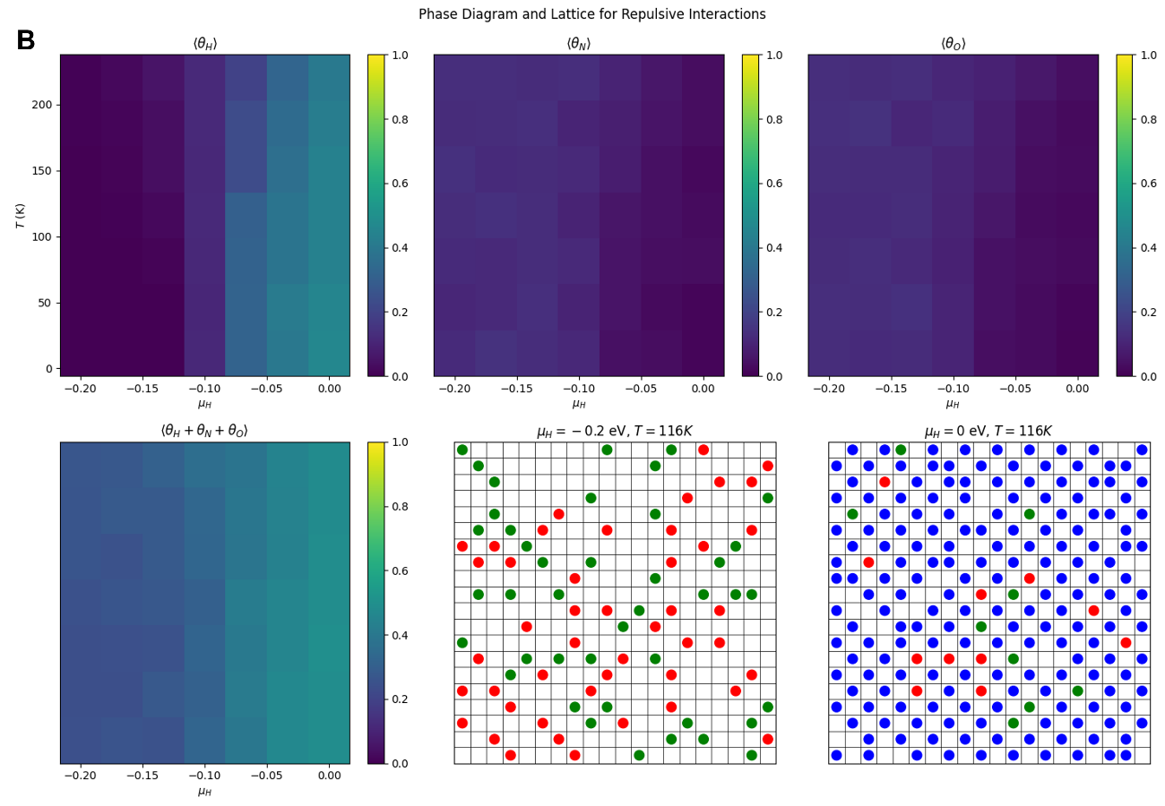

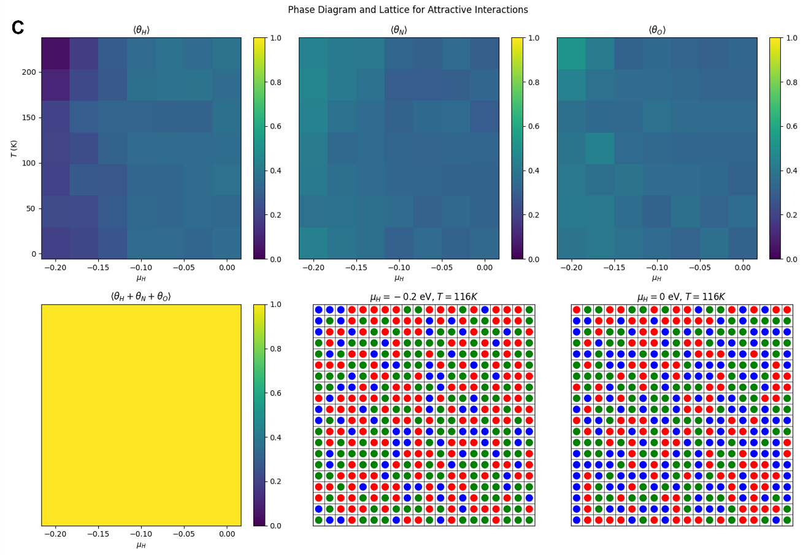

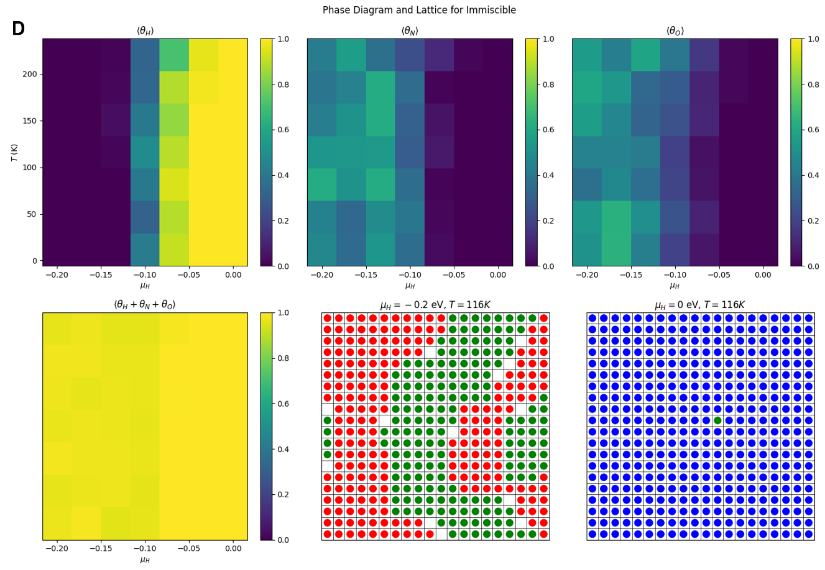

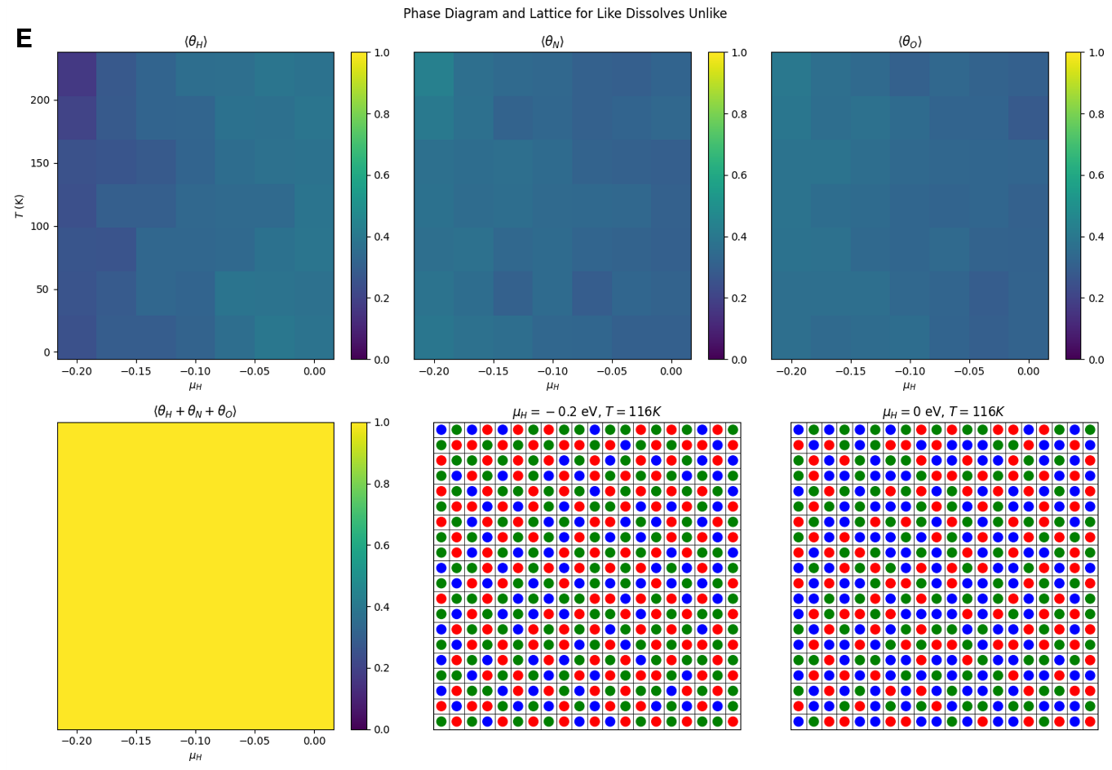

**Figure S4**. Phase diagram and lattice after introducing oxygen species for (A) ideal mixture (B) repulsive interaction (C) attractive interaction (D) immiscible case, and (E) like dissolves unlike case. The red circle denotes nitrogen, blue circle denotes hydrogen, and green circle denotes oxygen.

Adding a third adsorbate significantly increases the complexity of adsorption dynamics compared to two-adsorbate systems (**Figure S4A-E**). In the two-adsorbate case (hydrogen and nitrogen), competition for sites is straightforward, resulting in either mixed occupancy or segregation depending on interaction types. Introducing a third adsorbate (oxygen) requires considering multiple interactions simultaneously, leading to more diverse spatial distributions and complex phase behaviors. Two-species systems show distinct clustering or segregation. Three-species systems have mixed interactions that produce diverse patterns and less clear phase transitions. Three-component systems show more prevalent coexistence of adsorbates, especially with attractive interactions, resulting in a complex phase diagram with coexistence regions. Therefore, extending from two to three adsorbates creates a more complex struggle for lattice occupancy, leading to varied spatial arrangements and phase behaviors.